AWS Database

Why we have to use database?
Database plays crucial role in our application. We can store our customer data, sales data, power supply data, venders’ data or any kind of data in database. Main reason for storing data is to generate report. At end of the day how much sale we have done, how much profit or lose we got that all this details we will get it using database.

Database provide a structured, reliable, and efficient way to store, manage, and retrieve large amounts of data. They ensure accuracy, security, scalability, and fast access, which are essential for modern applications, businesses, and organizations.
Storing data in spreadsheets or flat files cannot handle effectively.

AWS Database Advantages:
1. Highly Scalable: We can scale your database as our application grows without any downtime.
Scaling in EC2 machine we have to do manually but in case of Database we don’t need to do it manually it will automatically be doing.
2. Fully managed: Everything from maintenance to hardware upgrade is managed by AWS.
AWS automates tasks like provisioning, backups, monitoring, and scaling. This includes:
- Infrastructure Management
- AWS takes care of hardware provisioning (servers, storage, networking).
- No need to worry about upgrading CPUs, memory, or disks—AWS automatically scales resources when needed.
- Software Maintenance
- Automatic patching: AWS applies security patches and updates to the database engine.
- Version upgrades: You can choose to upgrade to newer versions with minimal downtime.
- Provisioning & Deployment
- Databases can be launched in minutes using the AWS console or CLI.
- AWS handles cluster setup, replication, and failover configuration behind the scenes.
- Backups & Recovery
- Automated backups: Daily snapshots and transaction logs are stored securely.
- Point-in-time recovery: You can restore your database to any specific moment.
- Monitoring & Performance
- Integrated with Amazon CloudWatch for metrics like CPU, memory, query performance.
- Alerts and dashboards help you track health without setting up external tools.
- Scaling
- Vertical scaling: Increase instance size (CPU/RAM) with a few clicks.
- Horizontal scaling: Add read replicas or sharding (depending on the service).
- Many services (like DynamoDB) scale automatically based on traffic.
- High Availability & Reliability
- Multi-AZ deployments replicate data across availability zones.
- Automatic failover ensures minimal downtime if one node fails.
- Security
- Encryption at rest and in transit is built-in.
- Integration with IAM for fine-grained access control.
- Compliance with standards like HIPAA, PCI DSS, GDPR.

3. Workforce reduction: Since everything is managed by AWS, you don’t need a database maintenance team in your organization.
4. Enterprise class: AWS provides the same high-performance, resilient, and secure infrastructure used by Amazon’s own global e-commerce platform.
Types of AWS database:
• Relational Database- To work with RDBS you required SQL knowledge. This is oldest type of database we have in market. Oracle is the number one relational database in current market. Performance of oracle database is far much better than other database. Other than this all database types called as noSql database because to work on this no SQL knowledge is required.
• Key Value
• In Memory
• Document
• Wide Column
• Graph
• Time Series
• Ledger

• Key Value:
A key-value database is a type of non-relational database that uses a simple key-value method to store data. A key-value database stores data as a collection of key-value pairs in which a key serves as a unique identifier and a value serve as a associated data.
. It is NoSQL Database.
- It delivers single-digit millisecond performance at any scale.
- It’s designed for applications that need fast, predictable access to data without the overhead of managing servers or complex schemas.
We have seen tags in other services like EC2 and all. Tags is actually a key value type of data.

🚀 Use Cases
- Gaming: Player profiles, leaderboards.
- IoT: Sensor data ingestion at scale.
- E-commerce: Shopping carts, product catalogs.
- Mobile apps: Session management, user preferences.
- Real-time analytics: Fast lookups for dashboards.
- High traffic we applications

AWS’s primary key-value database service is Amazon DynamoDB

⚡ Amazon DynamoDB Features
- Fully Managed: AWS handles provisioning, patching, backups, scaling, and monitoring.
- Serverless: No servers to manage; scales automatically with demand.
- Performance: Consistent single-digit millisecond response times.
- Global Tables: Multi-region, multi-active replication for high availability (up to 99.999%).
- Security: Encryption at rest and in transit, fine-grained access control via IAM.
- Pricing: Pay-per-request billing—no upfront costs, you only pay for reads/writes.

Steps to create DynamoDB database in console:
Step 1: Open dynamoDB
- login to aws console.
- Search for DynamoDB in the services menu.

In memory Database:
Usually whenever we are installing anything in our system its getting installed in hard disc. But In memory database use memory of our computer.
- An in-memory database (IMDB) stores data directly in RAM instead of on disk (HDDs or SSDs).
Commonly used for:
- Real-time analytics (e.g., dashboards, fraud detection)
- Gaming leaderboards
- Session stores for web applications
- Caching layers to reduce load on primary databases.
AWS offers two main managed services for in-memory workloads:
• Amazon ElastiCache
• Amazon MemoryDB for Redis
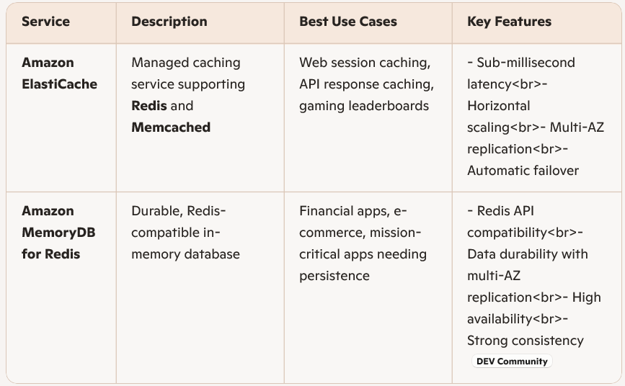

Document Database:
A document database stores data in a semi-structured format, usually JSON, BSON, or XML.
- Instead of rows and columns (like relational databases), data is organized into documents grouped in collections.
- Each document can have a flexible schema, meaning fields can differ between documents in the same collection.
The primary AWS service is Amazon DocumentDB (with MongoDB compatibility).
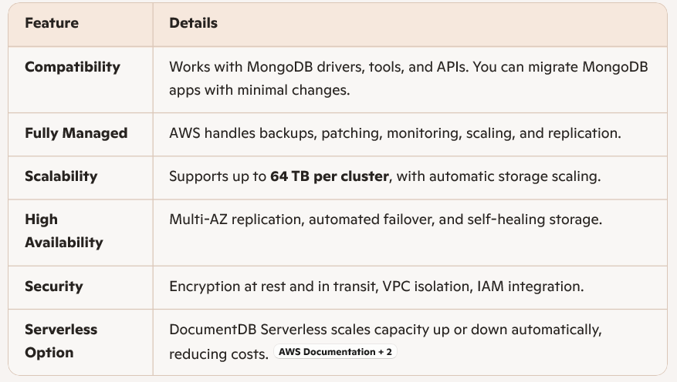
Advantages of Document Databases
- Flexible Schema: No need to predefine rigid structures.
- Developer-Friendly: JSON documents align with modern app development.
- Fast Iteration: Great for agile projects where requirements change.
- Rich Queries: Support for indexing, filtering, and aggregation.

